Evidencia 9 – Post 12/11/18

**Apellidos**: Jiménez Vega

**Nombre**: María

**Grupo**: Grupo 1

**Comité**: Comunicación

**Horas** **totales**: 1 hora 50 min

Evidencias:

1. Trabajé 50 minutos en organizar, escribir y enviar a igualdad los posts del día 11 de noviembre. AnexoII

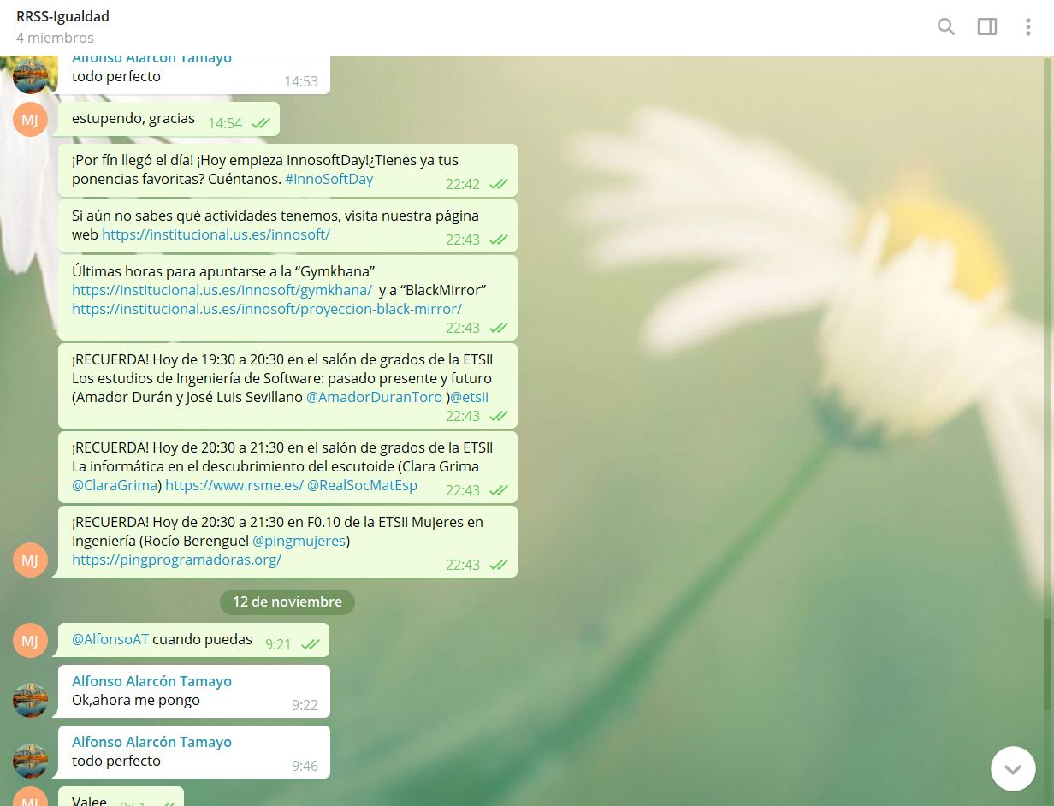

1. Trabajé durante 1 hora en subir los posts a las distintas redes sociales:
   1. Facebook
      1. <https://m.facebook.com/story.php?story_fbid=2218523695102692&id=1628847930736941>
      2. <https://m.facebook.com/story.php?story_fbid=2218553035099758&id=1628847930736941>
      3. <https://m.facebook.com/story.php?story_fbid=2218586238429771&id=1628847930736941>
      4. <https://m.facebook.com/story.php?story_fbid=2218661141755614&id=1628847930736941>
      5. <https://m.facebook.com/story.php?story_fbid=2218703535084708&id=1628847930736941>
      6. <https://m.facebook.com/story.php?story_fbid=2218732595081802&id=1628847930736941>
      7. <https://m.facebook.com/story.php?story_fbid=2218797451741983&id=1628847930736941>
      8. <https://m.facebook.com/story.php?story_fbid=2218846945070367&id=1628847930736941>
   2. Twitter
      1. <https://twitter.com/InnoSoftDays/status/1061911481531412480>.
      2. <https://twitter.com/InnoSoftDays/status/1061930604059607040>.
      3. <https://twitter.com/InnoSoftDays/status/1061930604059607040>
      4. <https://twitter.com/InnoSoftDays/status/1061952253941178369>
      5. <https://twitter.com/InnoSoftDays/status/1061983221485838336>
      6. <https://twitter.com/InnoSoftDays/status/1061998814507294720>
      7. <https://twitter.com/InnoSoftDays/status/1062015666381881349>
      8. <https://twitter.com/InnoSoftDays/status/1062052089558392836>
      9. https://twitter.com/InnoSoftDays/status/1062088148824584196